Lab 2 Evidences:

Create Panel with Product and Supplier Fields :

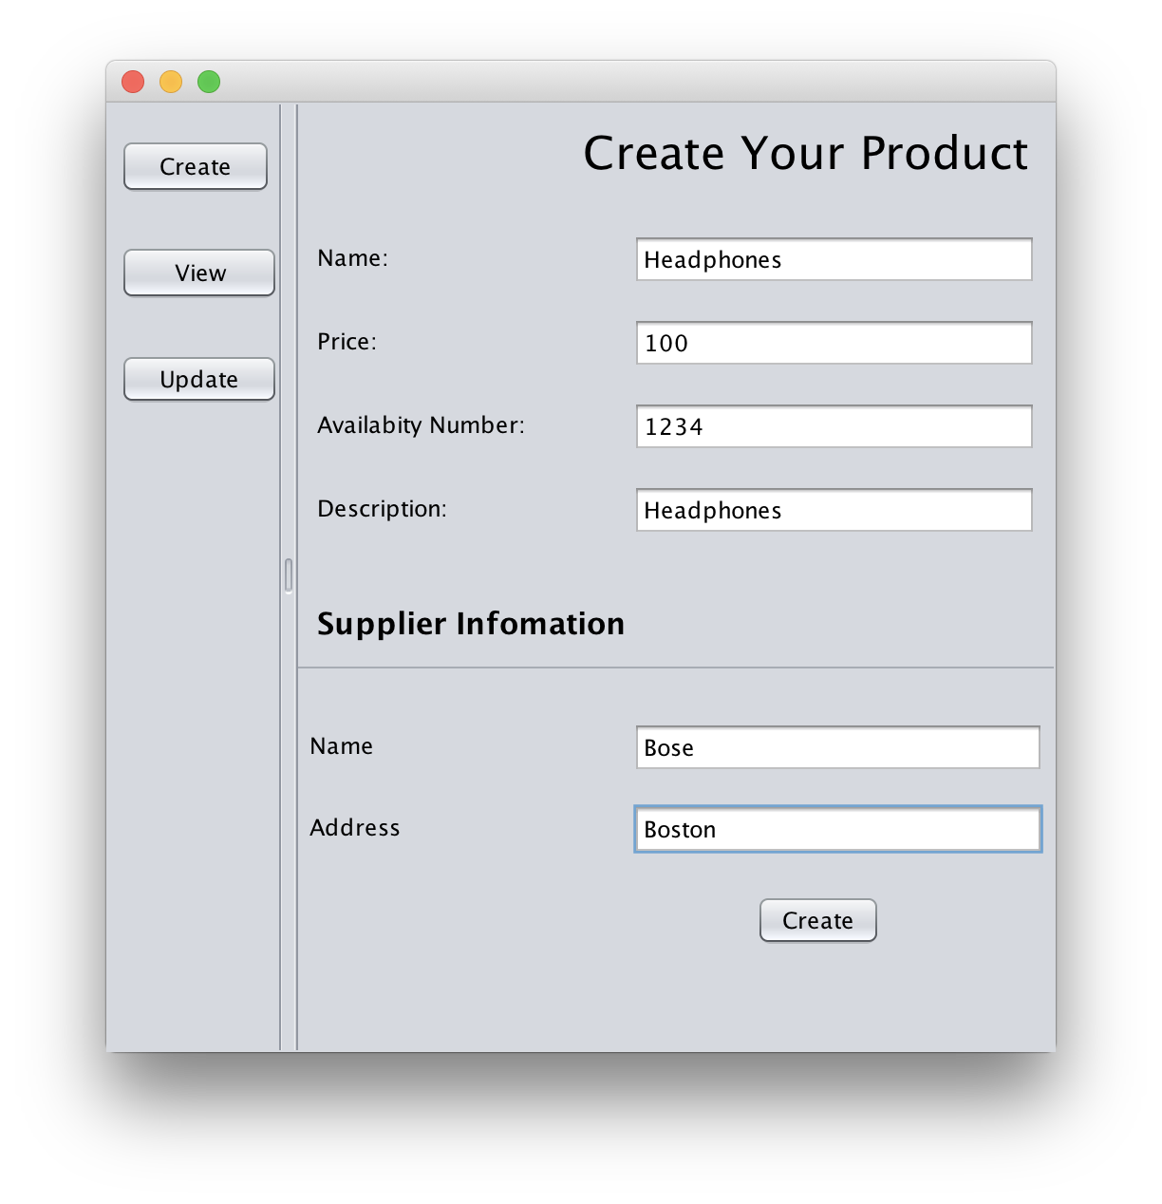

View Panel with Product and Supplier Fields:

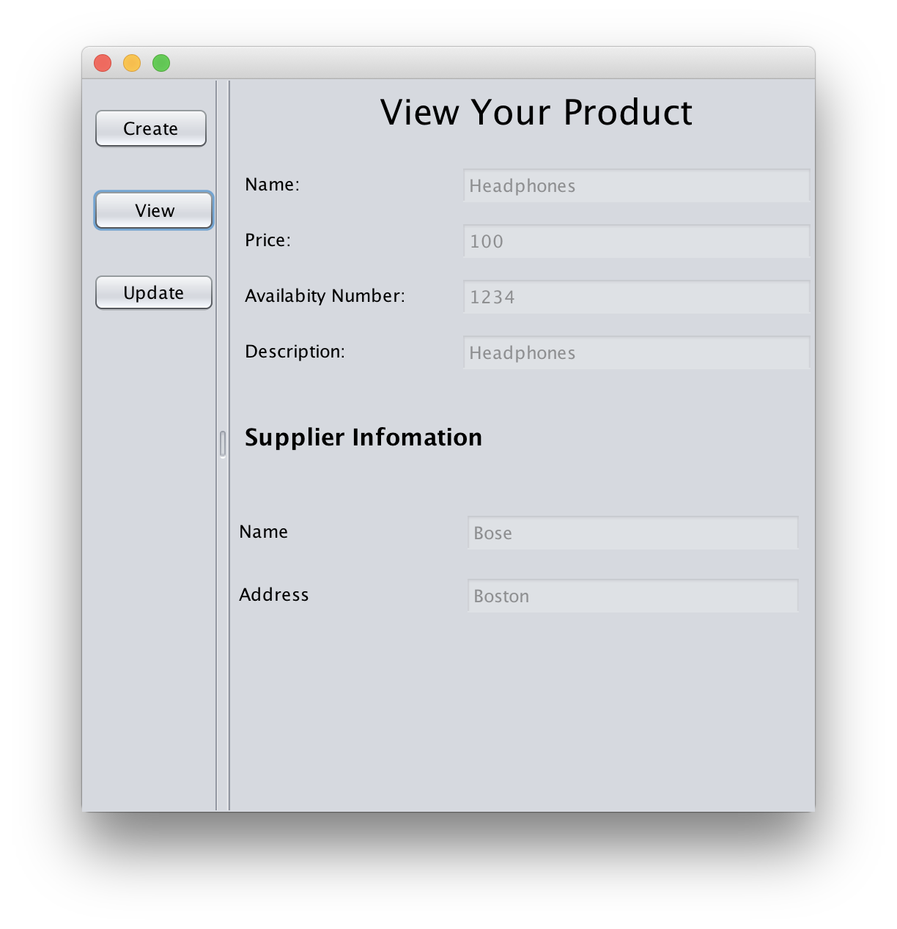

Update Panel with Product and Supplier Fields:

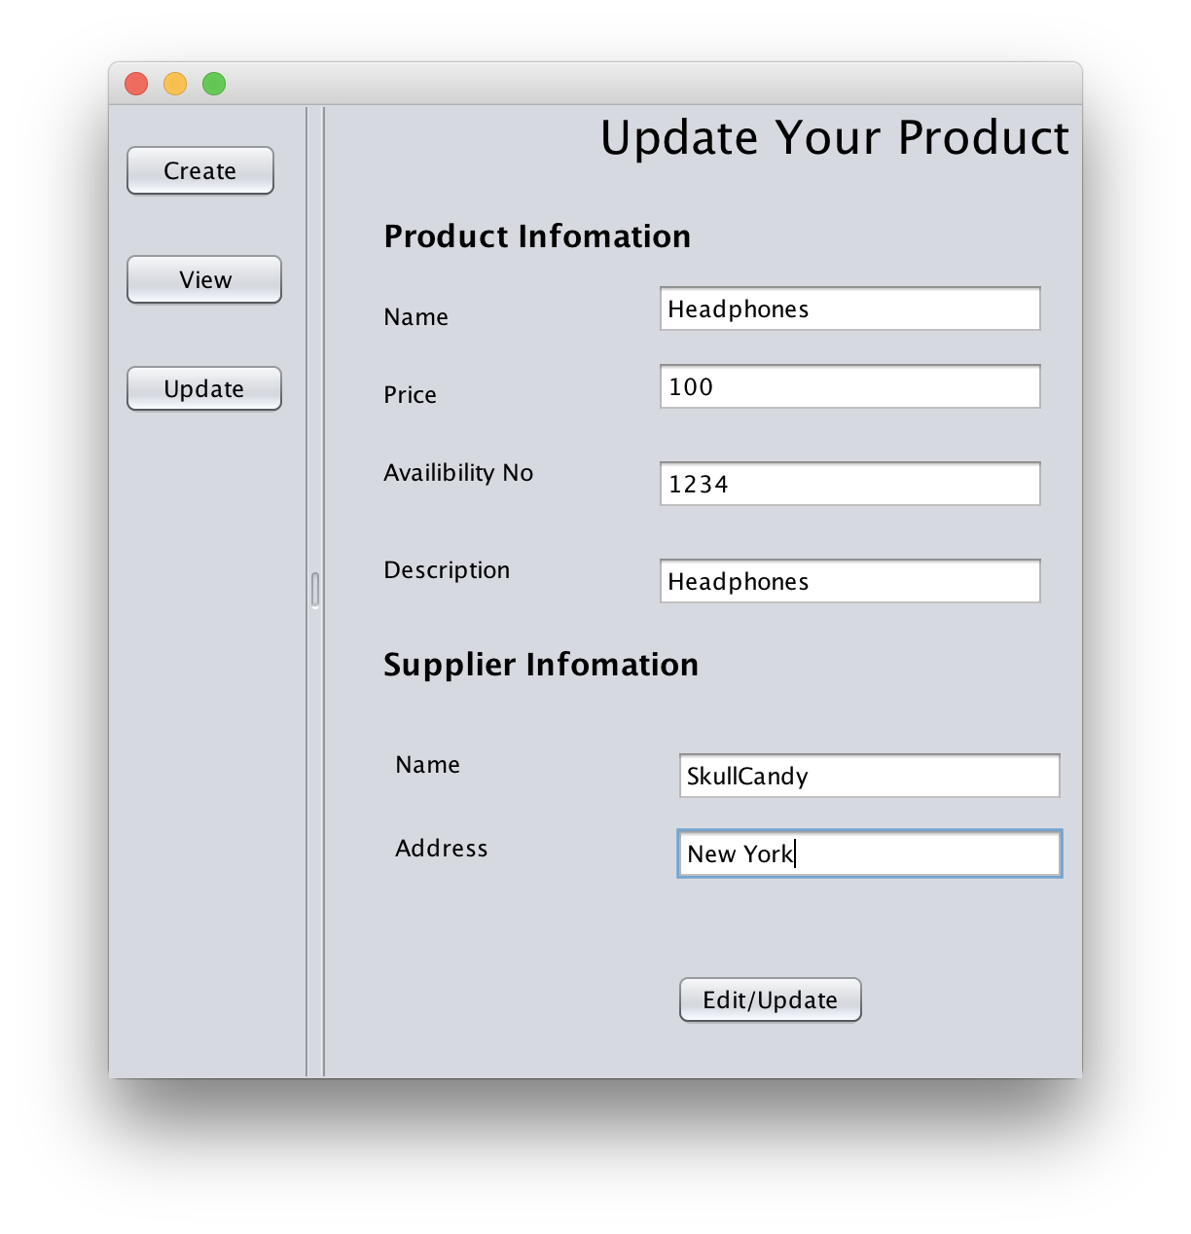

View Panel with UPDATED Product and Supplier Fields:

